Shri Ram College of Commerce
Commerce Department
01 Dec., 2021

Notice

Subject change requests for Generic Elective (Commerce)- Semester I

This is to inform the students who are desirous of changing their Generic Elective (Commerce) Paper - Semester I, may submit their application to the Time Table Convenor at ttc.commerce@srcc.du.ac.in latest by 03-12-2021 (Friday).

No requests shall be accepted post this deadline.

TTC Commerce

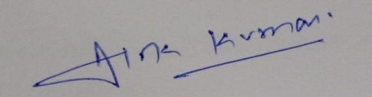

Dr. Alok Kumar

Dr. Alok Kumar
Convenor, TTC (Commerce)

